OpenShift Container Platform — Bare-Metal Cluster Installation Guide
Objective:

This document outlines the installation procedure for an OpenShift 4.16 cluster on a bare-metal environment. The setup consists of one Bastion VM and one Bootstrap VM, both hosted on KVM, along with three bare-metal servers that function as both control plane (master) and worker nodes.

Workflow:
- Log in to the KVM host and create one virtual machine for the Bastion node.
- Start the virtual machine and install the operating system.
- Configure the Bastion node as per the requirements.
- Create ignition files to configure the Bootstrap, Control Plane, and Worker nodes.
- Create a Bootstrap virtual machine on the KVM host and prepare the three bare-metal servers that will act as both Control Plane and Worker nodes.
- Configure the Bootstrap node using the ignition file.
- After configuring the Bootstrap node, configure the Control Plane nodes on the bare-metal servers.

Prerequisites:
- RHEL 9 OS installed and configured on the Bastion node
- RHCOS ISO installed and configured on the Bootstrap machine and bare-metal servers
- Pull secret
- Subscription Manager configured
- Domain name
- Cluster name
- Internet access to the Bastion node
- Free IP range for Bootstrap and three Master nodes
Start Configuring your Bastion Server:

  - After complete installation, set machine hostname as per requirements.
    - To set the hostname in machine
  - Check internet connectivity on machine before you can start the activity
    - ping 8.8.8.8
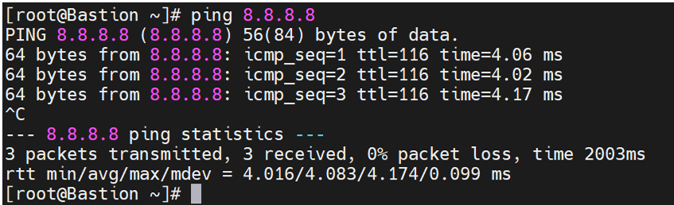
  - Setting the Redhat Subscription Manager:
    - subscription-manager register (provide username and password which is used to login in redhat console account)
    - subscription-manager status
  - disable firewall and selinux
    - For firewalld
i. Systemctl stop firewalld
ii. Systemctl disable firewalld
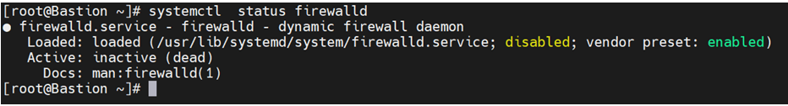
  - For Selinux :
i. Vi /etc/selinux/config (change selinux status to disabled state and save and exit from file)
ii. Check status of selinux
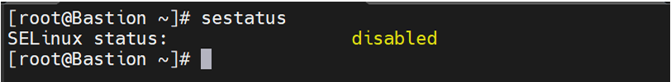
  - For reflecting changes restart the system.

Configure DNS server on the Bastion machine:
- Install named service
- yum install bind bind-utils -y
- systemctl start named
- systemctl enable named
- systemctl status named
- Write forward DNS and Reverse DNS zone file in configuration file
- Vi /etc/named.conf
- Add the Red colored text in file
options {
listen-on port 53 { 127.0.0.1; 172.25.250.10; };
listen-on-v6 port 53 { any; };
directory "/var/named";
dump-file "/var/named/data/cache_dump.db";
statistics-file "/var/named/data/named_stats.txt";
memstatistics-file "/var/named/data/named_mem_stats.txt";
secroots-file "/var/named/data/named.secroots";
recursing-file "/var/named/data/named.recursing";
allow-query { localhost; any; };

/*
- If you are building an AUTHORITATIVE DNS server, do NOT enable recursion.
- If you are building a RECURSIVE (caching) DNS server, you need to enable
recursion.
- If your recursive DNS server has a public IP address, you MUST enable access
control to limit queries to your legitimate users. Failing to do so will
cause your server to become part of large scale DNS amplification
attacks. Implementing BCP38 within your network would greatly
reduce such attack surface
*/
recursion yes;
dnssec-validation no;

managed-keys-directory "/var/named/dynamic";
geoip-directory "/usr/share/GeoIP";

pid-file "/run/named/named.pid";
session-keyfile "/run/named/session.key";

/* https://fedoraproject.org/wiki/Changes/CryptoPolicy */
include "/etc/crypto-policies/back-ends/bind.config";
};

logging {
channel default_debug {
file "data/named.run";
severity dynamic;
};
};

zone "." IN {
type hint;
file "named.ca";
};

zone "azalio.io" IN {
type master;
file "forward-zone";
allow-update { none; };
};

zone "250.25.172.in-addr.arpa" IN {
type master;
file "reverse-zone";
allow-update { none; };
};

include "/etc/named.rfc1912.zones";
include "/etc/named.root.key";

- Create 2 files in /var/named for forward and revers zone
- cd /var/named
- touch forward-zone reverse-zone
in this file the entry means
ocp-bastion.azalio.io = hostname of bastion
azalio.io = domain name
ocp = cluster name
172.25.250.10 = ip of bastion
172.25.250.15 = ip of bootstrap
172.25.250.20 = ip of master01
172.25.250.21 = ip of master02
172.25.250.22 = ip of master03

$TTL 1D
@ IN SOA ocp-bastion.azalio.io. root.azalio.io. (
0 ; serial
1D ; refresh
1H ; retry
1W ; expire
3H ) ; minimum
@ IN NS ocp-bastion.azalio.io.
@ IN A 172.25.250.10
ocp-bastion A 172.25.250.10
;================================================================

; Master Nodes
master01.ocp.azalio.io. IN A 172.25.250.20
master02.ocp.azalio.io. IN A 172.25.250.21
master03.ocp.azalio.io. IN A 172.25.250.22

; Temp Bootstrap Node
bootstrap.ocp.azalio.io. IN A 172.25.250.15

; OpenShift Internal - Load Balancer
api.ocp.azalio.io. IN A 172.25.250.10
api-int.ocp.azalio.io. IN A 172.25.250.10
*.apps.ocp.azalio.io. IN A 172.25.250.10

And same for reverse-zone file
$TTL 1D
@ IN SOA ocp-bastion.azalio.io. root.azalio.io. (
0 ; serial
1D ; refresh
1H ; retry
1W ; expire
3H ) ; minimum
@ IN NS ocp-bastion.azalio.io.
10 IN PTR azalio.io. #the last number of IP like in this 172.25.250.10
;===============================================================

; Master Nodes
20.250.25.172.in-addr.arpa. IN PTR master01.ocp.azalio.io.
21.250.25.172.in-addr.arpa. IN PTR master02.ocp.azalio.io.
22.250.25.172.in-addr.arpa. IN PTR master03.ocp.azalio.io.

; Temp Bootstrap Node
15.250.25.172.in-addr.arpa. IN PTR bootstrap.ocp.azalio.io.

; OpenShift Internal - Load Balancer
10.250.25.172.in-addr.arpa. IN PTR api.ocp.azalio.io.
10.250.25.172.in-addr.arpa. IN PTR api-int.ocp.azalio.io.

Then restart the named file
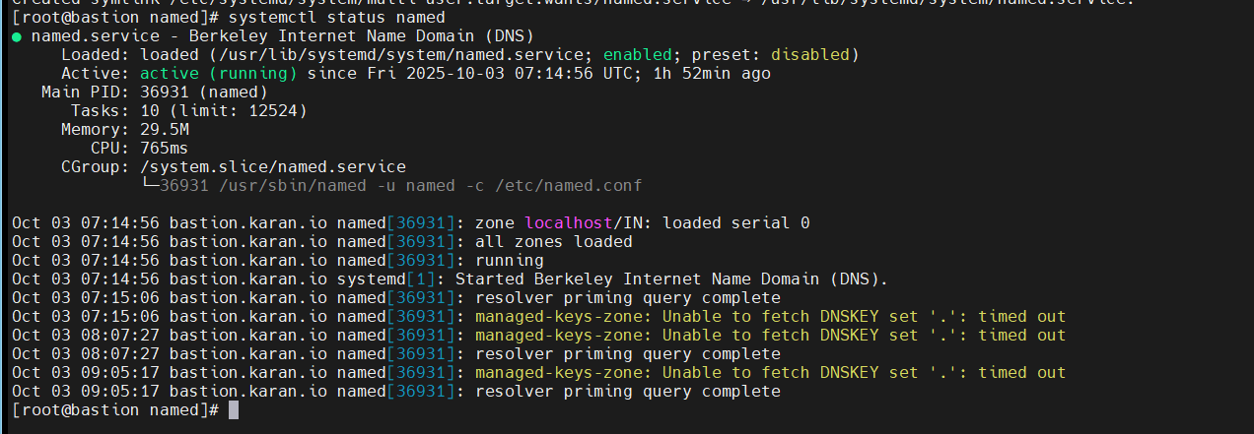
Give the entry in /etc/resolve.conf file
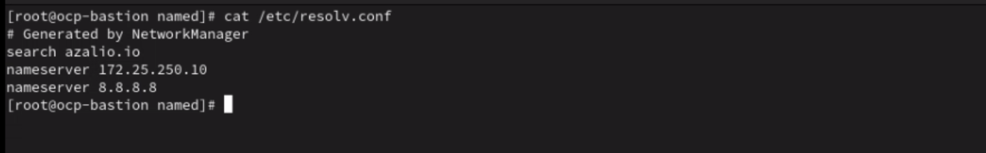
Then check our DNS working or not using the nslookup

- nslookup ocp-bastion.azalio.io
- nslookup azalio.io
- nslookup ocp-bastion
- nslooup master01.ocp.azalio.io.
- nslooup master02.ocp.azalio.io.
- nslookup master03.ocp.azalio.io.
- nslookup api.ocp.azalio.io.
- nslookup api-int.ocp.azalio.io.

Configure HAProxy LoadBalancer:
- Install HAproxy in system
- yum install haproxy
- systemctn restart haproxy
- systemctl enable happroxy
- Edit file and add details of cluster
vi /etc/haproxy/haproxy.cfg
remove all content from this file and add below content
global
log 127.0.0.1 local2
pidfile /var/run/haproxy.pid
maxconn 4000
daemon
defaults
mode http
log global
option dontlognull
option http-server-close
option redispatch
retries 3
timeout http-request 10s
timeout queue 1m
timeout connect 10s
timeout client 1m
timeout server 1m
timeout http-keep-alive 10s
timeout check 10s
maxconn 3000
listen api-server-6443
bind *:6443
mode tcp
option httpchk GET /readyz HTTP/1.0
option log-health-checks
balance roundrobin
server bootstrap bootstrap.ocp.azalio.io:6443 verify none check check-ssl inter 10s fall 2 rise 3 backup
server master01 master01.ocp.azalio.io:6443 weight 1 verify none check check-ssl inter 10s fall 2 rise 3
server master02 master02.ocp.azalio.io:6443 weight 1 verify none check check-ssl inter 10s fall 2 rise 3
server master03 master03.ocp.azalio.io:6443 weight 1 verify none check check-ssl inter 10s fall 2 rise 3
listen machine-config-server-22623
bind *:22623
mode tcp
server bootstrap bootstrap.ocp.azalio.io:22623 check inter 1s backup
server master01 master01.ocp.azalio.io:22623 check inter 1s
server master02 master02.ocp.azalio.io:22623 check inter 1s
server master03 master03.ocp.azalio.io:22623 check inter 1s
listen ingress-router-443
bind *:443
mode tcp
balance source
server master01 master01.ocp.azalio.io:443 check inter 1s
server master02 master02.ocp.azalio.io:443 check inter 1s
server master03 master03.ocp.azalio.io:443 check inter 1s
listen ingress-router-80
bind *:80
mode tcp
balance source
server master01 master01.ocp.azalio.io:80 check inter 1s
server master02 master02.ocp.azalio.io:80 check inter 1s
server master03 master03.ocp.azalio.io:80 check inter 1s

Restart the service and check the service status
- Systemctl restart haproxy
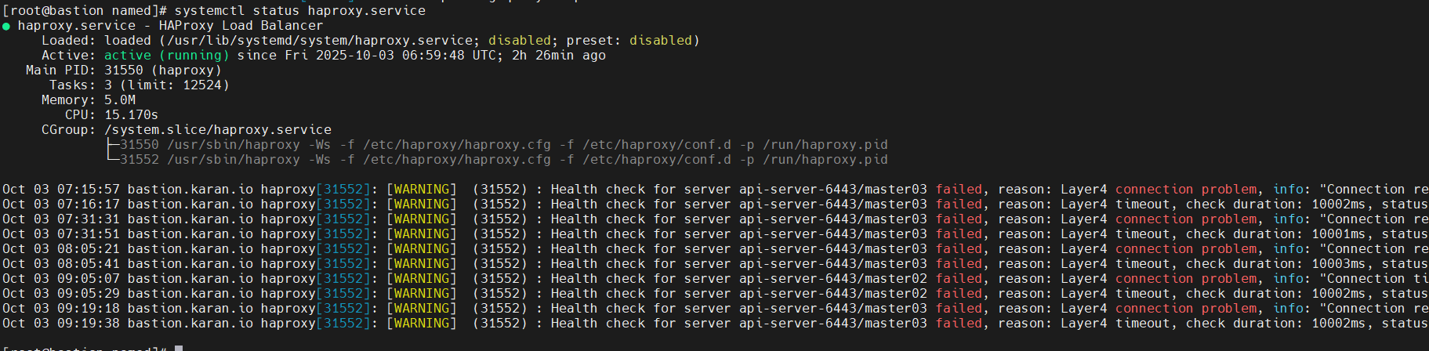
to check our named and haproxy running correctly or not
run this command
- dig +noall +answer @172.25.250.10 api.ocp.azalio.io
- dig +noall +answer @172.25.250.10 api-int.ocp.azalio.io
- dig +noall +answer @172.25.250.10 random.apps.ocp.azalio.io
- dig +noall +answer @172.25.250.10 console-openshift-console.apps.ocp.azalio.io
- dig +noall +answer @172.25.250.10 bootstrap.ocp.azalio.io
- dig +noall +answer @172.25.250.10 -x 172.25.250.10
- dig +noall +answer @172.25.250.10 -x 172.25.250.23

Configure Webserver:

- Install httpd Package in system
- yum install httpd -y
- Change listen port from 80 to 8080 in configuration file
- Vi /etc/httpd/conf/httpd.conf
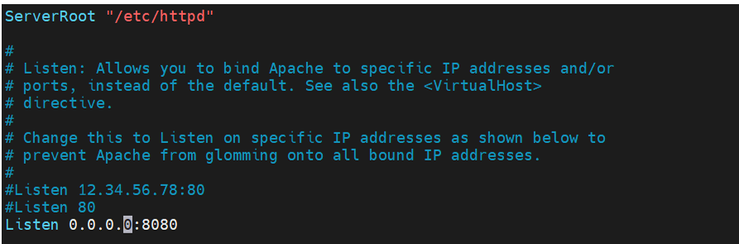
- Restart the Service and enable it

Generate Ignition files.
- Download OpenShift Installer
- wget https://mirror.openshift.com/pub/openshift-v4/clients/ocp/4.16.0/openshift-client-linux-4.16.0.tar.gz
- Download OpenShift client
- wget https://mirror.openshift.com/pub/openshift-v4/clients/ocp/4.16.0/openshift-install-linux-4.16.0.tar.gz
- untar both and tar file
tar -zxvf openshift-client-linux-4.16.0.tar.gz
tar -zxvf openshift-install-linux-4.16.0.tar.gz

- Record the pull secret
- Use the following link to copy or download the pull secret for installation. Use login and password which used for subscription manager.
https://console.redhat.com/openshift/create/local
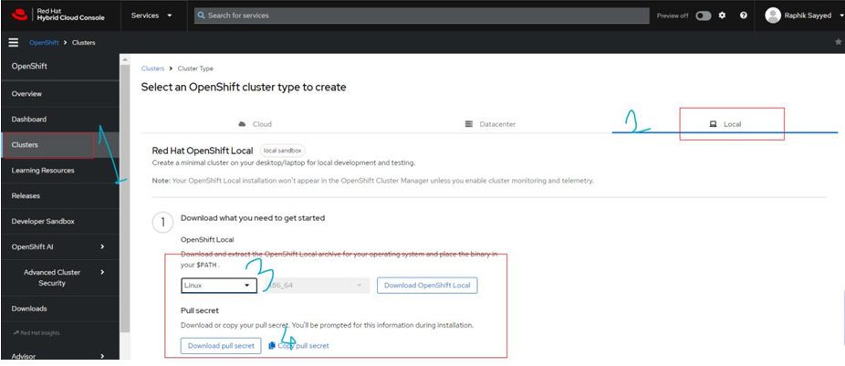
- Create SSH key for bastion
- Create ssh-key by using command
- Use ssh-keygen command to create ssh keys and copy data from id_rsa.pub file from .ssh directory.
- Create directories to create ignition files
- mkdir -p /root/ocp-installation
First create/write the install-config.yaml file
- vim install-config.yaml
❖ Pull- secret: This file contains the complete content of text in pull secret file
❖ SSH key: Add the content of id_rsa.pub file
❖ All the commas here should not be changed. This can give invalid ending error.
❖ You can keep a copy of this file, as this will be consumed, and new file are created.

apiVersion: v1
baseDomain: azalio.io
compute:
- hyperthreading: Enabled
name: worker
replicas: 0
controlPlane:
hyperthreading: Enabled
name: master
replicas: 3
metadata:
name: ocp
networking:
clusterNetwork:
- cidr: 10.128.0.0/14
hostPrefix: 23
networkType: OVNKubernetes
serviceNetwork:
- 172.30.0.0/16
platform:
none: {}
fips: false
pullSecret: '{"auths": ...}'
sshKey: 'ssh-ed25519 AAAA...'

- Generate manifests
- Manifest directory is created after applying following command
- Go to /root/ location and hit the following command
./openshift-install create manifests --dir ocp-installation
- Now edit the scheduler setting to disable pod deployment on master
▪ Edit the cluster-scheduler-02-config.yaml file (change from true to false in file)
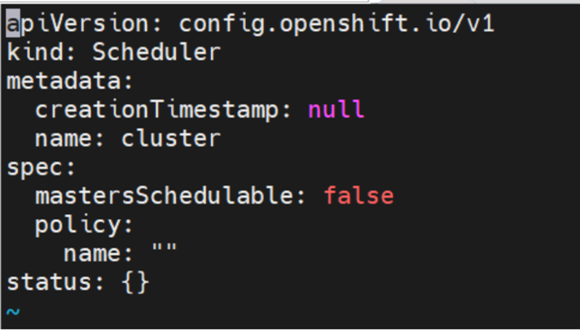

- Generate Ignition Files
- By using following command, we create ignition file
./openshift-install create ignition-configs --dir ocp-installation
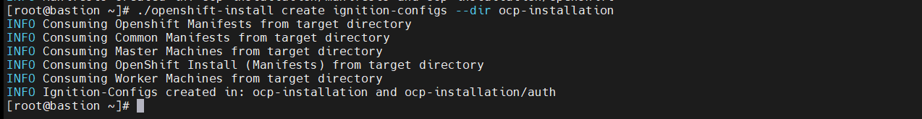
- This are important files
▪ /ocp-installtion directory contains the ignition files for bootstrap, control plane and worker node to join the machines in OCP cluster.
▪ /ocp-installation/auth directory contain kubeconfig file and password that will used to console login into the cluster
- Configure ignition files on webserver.
- Copy all created ignition files to webserver directory and provide required permission to that.
▪ mkdir -p /var/www/html/ocp
▪ cp /root/workspace/ocp/*.ign /var/www/html/ocp/
▪ chmod -R 755 /var/www/html/ocp/*
▪ Confirm that the ignition files are accessible from web, to check it Browse url http://<IP of bastion>:8080/ocp
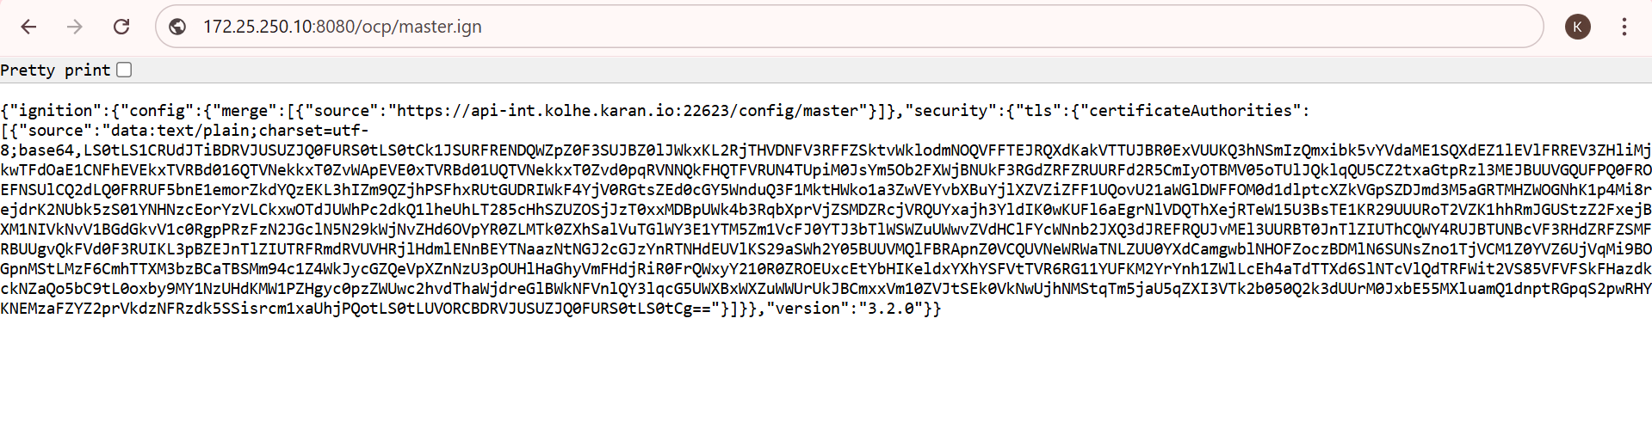
Configure Bootstrap Machine:

To get the bootstrap VM up and running, we need the machine to be booted using KVM. Following are the steps:
• Open the console view of KVM server and create new machine as per requirements.
• Attach the rhcos live iso to the machine to be used during boot
• Edit the boot option to use CD/DVD
• Start the machine and install and configure the RHCOS vm
Bootstrap Node Configuration:

Align Time Zone with Bastion Node
Ensure the Bootstrap node’s time zone matches the Bastion node:
timedatectl set-timezone <Bastion_Timezone>
timedatectl status
Assign a Static IP Address
Configure the network interface enp0s3 with a static IP:
- nmcli connection modify enp0s3 ipv4.addresses 172.25.250.15/24 ipv4.method manual ipv4.gateway 172.25.250.1 ipv4.dns 172.25.250.10
- nmcli connection down enp0s3
- nmcli connection up enp0s3
Set the Hostname
Assign the hostname for the Bootstrap node:
- hostnamectl set-hostname bootstrap.ocp.azalio.io
install RHCOS Using Ignition File
Apply the ignition configuration file to the Bootstrap node:
- sudo coreos-installer install /dev/vda \
--ignition-url=http://172.25.250.10:8080/ocp/bootstrap.ign \
--insecure-ignition \
--copy-network
Reboot the Bootstrap Node
- sudo reboot
time zone of bootstrap is aligned with the bastion
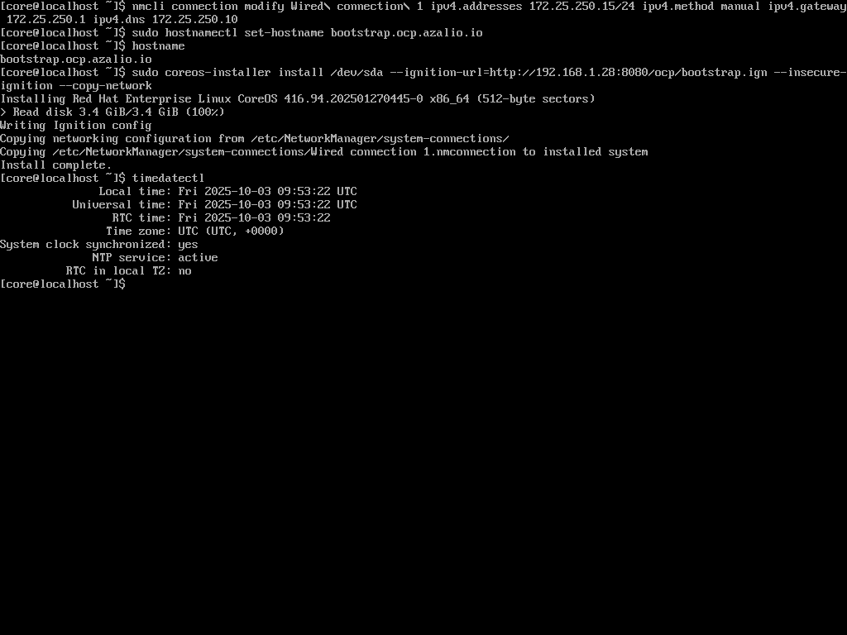
Master Node Configuration
Align Time Zone with Bastion Node
Ensure each Master node’s time zone matches the Bastion node:
- timedatectl set-timezone <Bastion_Timezone>
- timedatectl status
Assign a Static IP Address
Configure the network interface with the assigned static IP for each Master node.
(Replace <interface> and <IP> with the appropriate values for each server.)
- nmcli connection modify <interface> ipv4.addresses <IP>/24 ipv4.method manual ipv4.gateway 172.25.250.1 ipv4.dns 172.25.250.10
- nmcli connection down <interface>
- nmcli connection up <interface>
Set the Hostname
Assign the hostname for each Master node:
- hostnamectl set-hostname <masterX>.ocp.azalio.io
Example:
  - master01.ocp.azalio.io
  - master02.ocp.azalio.io
  - master03.ocp.azalio.io
Install RHCOS Using Ignition File
Apply the ignition configuration file to each Master node:
- sudo coreos-installer install /dev/vda \
--ignition-url=http://172.25.250.10:8080/ocp/master.ign \
--insecure-ignition \
--copy-network
- Reboot the Master Node
- sudo reboot

